


SCOTT LEIBFRIED
Executive Chef
SOLEIL@K
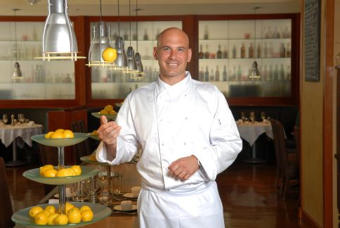
As executive chef for Soleil@k, one of downtown San Diego’s up and coming dining scene, Chef Scott Leibfried focuses on very simple, fresh and healthy cuisine, that emphasizes on local, seasonal ingredients from both land and sea. At Soleil@k, Leibfried encourages his guests to experience one part of the new menu structure, which is the ultimate San Diego lifestyle of easy and laid-back attitude by offering large portions for the tables that promote sharing and conversation.

Leibfried comes from a long line of produce farmers, dating back to the early 30’s. From his family roots, he gained a comprehension and passion for food by understanding and appreciating where food comes from. As a teenager, Leibfried discovered his passion for culinary and pursued his dream to become a chef at Johnson and Wales University in Rhode Island. Upon his graduation, he traveled all over the Northeast and Europe working with respected chefs to gain the best experiences to acquire the craft of cooking. During his travels, he gained the knowledge and understanding of food quality, culture and how food relates to lifestyles.

In 1997, Leibfried relocated to the West Coast as chef for the Four Seasons Hotel in Beverly Hills where he supervised all kitchen departments, menu development, and special events. There he learned how important every detail is and how demanding the very best of ingredients equals excellence- a motto he continues to practice everyday.

In 2002, he accepted a position as the executive chef for Napa Valley Grille in Westwood, Calif. As executive chef, he was responsible for the creation of recipes by continuing to develop the style and improve the quality of food. While working at Napa Valley Grille, Leibfried discovered his style of cooking that he enjoys.

Prior to becoming the executive chef at Soleil@k, Leibfried worked in Michelin rated restaurants owned and operated by Chef Gordon Ramsey in London. He was also recently a member of an independent task force, that is a restaurant consulting firm that constructs, implements and conceptualizes independent restaurants and hotels.

Chef Scott Leibfried can presently be seen on the hit television show “Hell’s Kitchen” as a sous chef for the FOX Network and has appeared several times on The Food Network’s hit series, “Party Starters” and the “Challenge” series. Chef Leibfried is well respected in the industry and has been invited as a guest Chef at the James Beard House, Crystal Cruise Lines and at Nationwide Food and Wine Expos.

Leibfried is a regular at many local farmers markets, as well as a frequent traveler to California Wine Country. His style of cooking is taking the finest ingredients and cooking them in their simplest form without disguising them.

